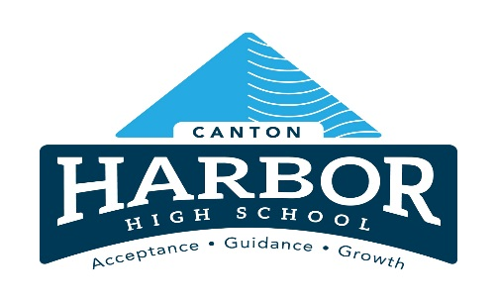

**Policy No. 3631**

**Canton Harbor High School Career Advising Policy**

Updated 9/11/2024

This policy on career advising is reviewed at least once every two years and made available to students, parents, guardians and custodians, local post-secondary institutions and district residents. The policy is posted in a prominent location on the Canton Harbor High School website.

The district’s plan for career advising includes, providing:

1. Grade-level examples that link students' schoolwork to one or more career fields by implementing the Career Connections Learning Strategies offered by the Ohio Department of Education.
2. Career advising to students in grades 6-12, which includes meeting with each student at least once annually to create and or update academic and career pathway opportunities.
3. Additional interventions and career advising for students who are identified as at risk of dropping out of school. These include:
   1. Identifying students who are at risk of dropping out of school using a local, research-based method with input from teachers, school counselors and other appropriate school staff.
   2. Developing a College and Career Success plan for each at-risk student that addresses both the student's academic and career pathway to successful graduation and the role of career-technical education, competency-based education and experiential learning, when appropriate.
      1. Before a district develops a pupil's Student Success Plan, district staff will invite the student's parent, guardian or custodian to assist. If that adult does not participate in the plan development, the district will provide the adult a copy of the plan, a statement of the importance of a high school diploma and a listing of the pathways to graduation available to the student.
4. Training for employees on how to advise students on career pathways, including use of the tools available in Ohio Means Jobs K-12 and other online sources provided by the district.
5. Multiple academic and career pathways through high school that students may choose to earn a high school diploma, including opportunities to explore, shadow, intern, volunteer, or work-placement in multiple career fields of their interest.
6. Information on courses that can award students both traditional academic and career-technical credit including, but not limited to, the District's policy on credit flexibility and instructions for students to access the educational option.
7. Documentation on career advising for each student and student's parent, guardian or custodian to review, as well as schools that the student may attend in the future. These include activities that support the student's academic, career and social/emotional development.
8. The supports necessary for students to successfully transition from high school to their postsecondary destinations, including interventions and services necessary for students who need remediation in mathematics and English language arts.
9. See Career Based Intervention Course of Study, Unit 1: Postsecondary and Career Preparation.
10. Provide students with information about ways a student may offset the costs of a post-secondary education, including programs such as all of the following:
    1. The reserve officer training corps;
    2. The college credit plus program established under Chapter 3365. of the Revised Code;
    3. Expanding Opportunities for Each Child Non-competitive grant
    4. The Ohio guaranteed transfer pathways initiative established under section 3333.168 of the Revised Code;
    5. Joint academic programming or dual enrollment opportunities required under section 3333.168 of the Revised Code.